# Analysis of a scientific article

## Identification of the students:

|  |  |
| --- | --- |
| Names of the students | 1. Jonas Bertels |
|  | 2. Yoshi Vermeire |
|  | 3. |

## Identification of the article:

|  |  |
| --- | --- |
| Title of the article | Available Power Gain, Noise Figure, and Noise Measure of Two-Ports and Their Graphical Representations |
| Author(s) | H. Fukui |
| Journal  (title, year, volume, edition, pp.) | IEEE Transactions On Circuit Theory, 1966, volume CT-13, No. 2, page 137 |

## Declaration

The analysis submitted is original work, in which we (I) do not use the ideas or wording of anyone else without proper referencing or quoting. We (I) have read the guidelines of the Faculty of Engineering Science and are (am) applying these guidelines (<https://eng.kuleuven.be/en/study/plagiarism>). We are (I am) aware of the sanctions that may result from plagiarism or any other irregularity as defined in the article 84 to 86 of the examination regulations of the KU Leuven (<https://www.kuleuven.be/education/regulations/2018/#art84>).

## Analysis of the content of the article:

### 1. What is in your own words the main message of the article (≠ abstract)?

It is possible to express the performance metrics of linear two ports as a function of the source impedance, the gain parameters and the noise parameters. This paper focusses on the noise measure and the available gain as import performance metrics.

It is convenient to visualize these different performance metrics of an amplifier over a wide range of source admittances on the Smith chart during the design phase of the amplifier, since one can plot those performance metrics in simple geometric shapes.

### 2. Which are the basic assumptions on which this article relies? (This *can have different formats: e.g. a model that has been used and of which one assumes it is sufficiently accurate for the purpose, or the assumption that only linear effects are important in an active circuit, or the assumption that a new type of circuit should always be better than previous ones,…).*

### Convenient representation

The author assumes that the geometric places where the performance parameters stay constant, are convenient ways to investigate the influence of the source impedance on the performance. The importance of this paper also depends on the assumption that designers of linear two ports need to visualize the parameters like noise and gain.

### Noise figure expression

The author starts from the idea that the noise figure can be expressed in terms of the source impedance using the following expression:

The author justifies this assumption by referencing the book, *IRE Standards On Electron Tubes Methods of Testing;* In the appendix of part 9 of this book we find a derivation of this formula.

### Available Power Gain Expression

The paper assumes the correctness of the expression for the available power gain in function of the two port parameters and the source impedance:



This formula can be derived using a procedure described by Linvill and Gibbons in their book *Transistors and Active circuits.*

### 3. Reformulate in your own words the fundamental reasoning that is made in the article.

This paper searches for more convenient ways to investigate the performance of linear two ports over a wide range of source impedances.

It starts from the basic expression for or definition of the performance parameters, for example the noise measure, defined as:

This expression is then rewritten to explicitly contain the source impedance.

Next, the paper rewrites the expression to a formula from which it is more convenient to derive a simple geometric shape as the geometric place; for example, the author transformed the expression for the available power gain from:



to:

The plots of these expression result in families of circles. At the last step, the resulting equations are interpreted, with a focus on points like the minimum and their representation on the graph.

### 4. Do you agree with the content and conclusions of the article? Why? (You may check some of the mathematics to come to your decision.).

### Expression for the Available Gain

Using some Berkeley Lecture notes (Niknejad, 2005), we can derive the expression for the available power gain as follows:

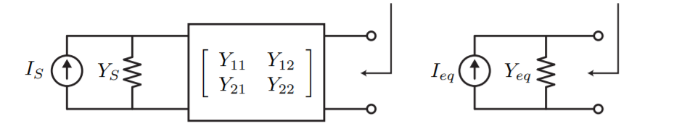

Figure 1: Linear two port and its Norton equivalent

We will use a Norton equivalent as shown in *figure 1:*

Using this, we can calculate

This simplifies to:

,

since equals .

### Alternate Expression for The Power Gain

 (1)

With the following parameters:

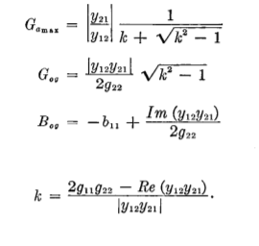

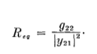

If we plug in the values, we get the following:

Now we calculate the factor :

Then we can calculate the expression :

(And of course: Re{a+bj}+Re{c+dj} = a + c = Re{a+bj+c+dj} so we can add the last 2 statements together to get the following:)

… and if we take the inverse of both sides, we get the expression that we calculate in the section above:

.

We can easily transform this expression into this following shape:

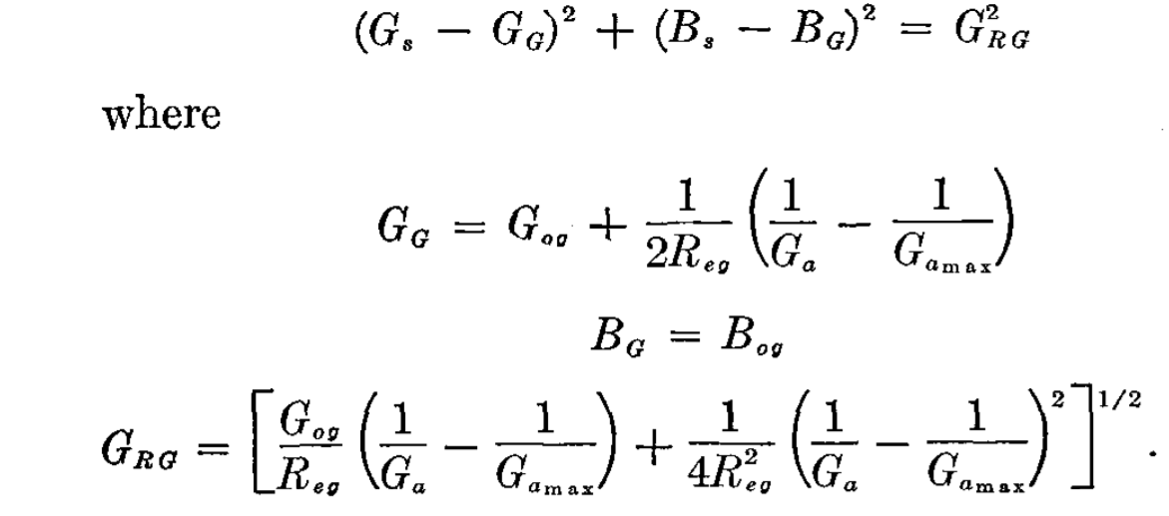 (2)

If we define an X equal to , we can rewrite the alternative expression (1) to the following form: . (3)

Since we have that is equivalent to

, we can rearrange equation (3) to the desired expression (2).

Because Ga is smaller or equal to Gamax, the radius GRG is always positive; hence, the result is a real family of circles.

### Constant Noise Measure Locus

(4)

We define the variables C1 and C2 in order to reshape this equation:

and .

Now, we can rewrite the expression:

(5)

This equation has the following form: , (6)

where x and y represent Gs and Bs respectively. We can rearrange that expression (6) to:

. Hence, we can rewrite (5) to the following form:

GM equals

,

BM equals , and

GRM equals

We have that

and

.

Combining those two equations, we get an expression for :

+

The previous equations result in the following expression for GRM :

+

+

(7)

We make the two denominators the same:

Now, we can simplify expression (7) to:

One cannot simplify this last expression in any meaningful way. The careful reader might have noticed that this expression does not equal the expression in the original paper:

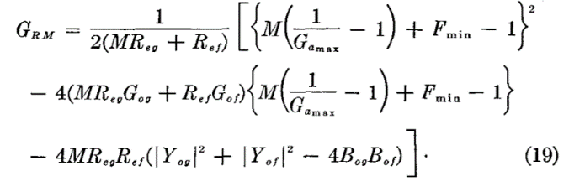 .

Though we suspect that the original paper contains a small error, the overall results are still valid: the constant M loci are circles on the rectangular plane.

We decided to plot the absolute difference of (GS - GM)² + (BS - BM)² our formula and Fukui’s formula (assuming Fukui meant to write GRM² when he wrote (19) (this gives a result which aligns much more closely, but not perfectly).

We seeded the MATLAB random number generator 10 times to generate the necessary parameters and got the following result:

We can clearly see that the difference between our estimate of (GRM)² and the value given by (GS - GM)² + (BS - BM)² is close to machine precision, or even 0, while the value of Fukui’s GRM² is, while fairly low, not quite the same.

Since Fukui then sets GRM to zero, there is no further impact on the article.

### Bilinear Transformations

A bilinear transformation is a transformation of the following type:

, where the product of a and d minus the product of c and b does not equal zero. The transformation used in this paper is .,

and . This is indeed a bilinear transformation. As we can read in this chapter [1], such a bilinear transformation maps circles on the complex plane into circles on the reflection coefficient plane.

### 5. Where and how can the content of this article be applied following you? (You may mention applications indicated in the paper, but also try to come up with your own ideas.)

### 6. Are there any terms (definitions), or other background information, that you needed to look up in order to understand the article? If yes, explain.

* Paper refers to original paper of Rothe and Dalke “Theory of Noisy fourpoles”, which was found and from which we got the following figure describing the noise figure on a rectangular coordinate system.

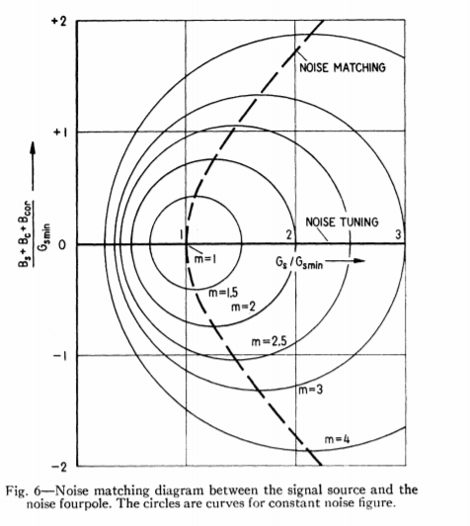

* The Berkeley Lecture slides to understand how we could express the amplifier gain as used in the article (the original paper by Linvill and Gibbons could not be found)
* The book *Standards On Electron Tubes Methods of Testing* provided us with a derivation of the noise formula.
* Chapter 9 from Pulak Sahoo gave us the proof that bilinear transformation indeed transform circles into circles.
* We weren’t familiar with the unit millimhos. This unit is equivalent to millisiemens, and is used to express conductivity.

## Analysis of the format of the article:

### 1. Is the article written a sufficiently clear language?

### 2. Are the graphs sufficiently clear?

### 3. Do the captions to the figures and tables contain sufficient information in order to understand them (and possibly reconstruct them)?

### 4. What is the importance / the function of the references to which this article refers? Which reference is the crucial one (explain)? (Add this reference in pdf to your analysis)

The majority of the references introduces the basic concepts used to derive the results of this paper: the definitions of important concepts as noise measure and the coordinates of the Smith chart, fundamental assumptions like the dependence of the noise figure on the source impedance…

Another reference points to a previous result, the graphical representation of the noise figure in the source admittance plane. This paper improves upon this result by using the noise measure and another coordinate system.

# Bibliography

[1] Niknejad, A. M. (2005). *Lecture 4.* Retrieved from Berkely University RF & IC: http://rfic.eecs.berkeley.edu/~niknejad/ee142_fa05lects/pdf/lect4.pdf

[2] The Institute of Radio Engineers, Inc. (1962). IRE Standards On Electron Tubes Methods Of Testing. *Institute of Radio Engineers (IRE)*, (p. 160). New York.

**[3]** Pulak Sahoo *Chapter 9 Conformal Mapping and Bilinear Transformation*

Retrieved from: <http://epgp.inflibnet.ac.in/epgpdata/uploads/epgp_content/S000025MS/P001475/M016947/ET/1468564049EText(Ch-9,M-2.pdf>

<http://rfic.eecs.berkeley.edu/~niknejad/ee142_fa05lects/pdf/lect4.pdf>

<https://archive.org/details/IRE1962IREStandardsOnElectronTubesMethodsOfTesting62IRE7.SI/page/n145>